CHAPTER 5: IMPLEMENTATION AND TESTING
5.1 Implementation Approaches
The StyleCart project is implemented using the MERN Stack (MongoDB, Express.js, React, Node.js), following a modular Model-View-Controller (MVC) architectural pattern on the backend and a component-based architecture on the frontend.
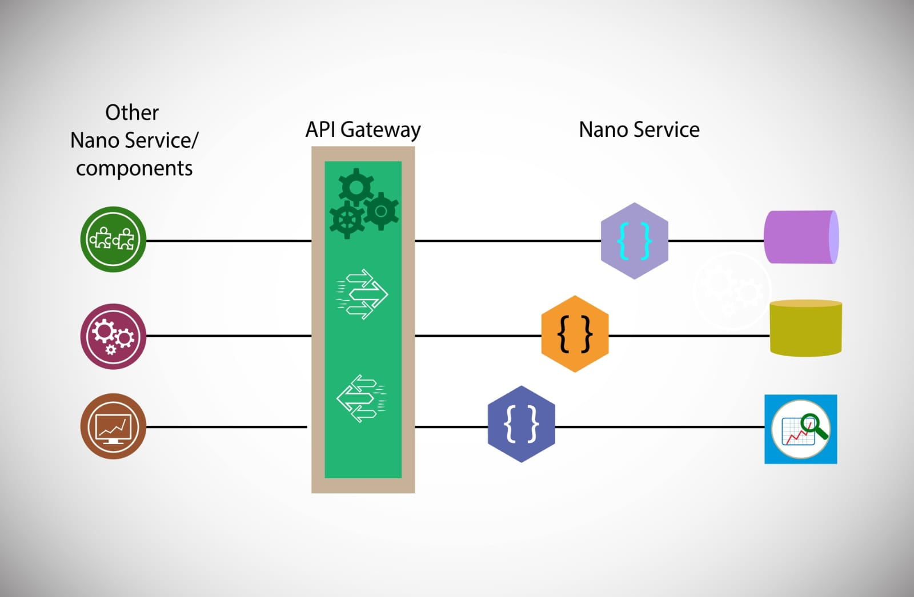
Backend Implementation:
Node.js & Express.js: Used to build a scalable RESTful API.
MongoDB & Mongoose: Used for data persistence with structured schemas for users, products, and orders.
JWT (JSON Web Tokens): Implemented for secure, stateless authentication.
Cloudinary: Integrated for efficient image management and storage.
Frontend Implementation:
React 19: Utilized for building a dynamic, single-page application (SPA).
Context API: Employed for global state management (Shop, User, and Auth contexts).
Tailwind CSS 4: Used for modern, responsive styling with a utility-first approach.
React Router: Handles seamless navigation between pages.
5.2 Coding Details and Code Efficiency
The codebase prioritizes readability, reusability, and performance.
5.2.1 Code Efficiency
Memoization & State Optimization: Utilizing React's hooks (useState, useEffect) effectively to minimize unnecessary re-renders.
Global State Management: By using the Context API, data such as user authentication status and cart contents are shared across the application without "prop drilling," improving performance and maintainability.
Lazy Loading: Frontend assets and components are managed to ensure fast initial load times.
Database Indexing: Mongoose models are designed to use unique identifiers and optimized queries for faster data retrieval.
5.3 Testing Approach
The testing strategy for StyleCart focuses on ensuring reliability, security, and a seamless user experience.
5.3.1 Unit Testing
Individual modules and functions are tested in isolation.
Backend: Testing controllers for expected status codes and JSON responses.
Frontend: Testing individual UI components like Nav, Hero, and Footer for correct rendering.
5.3.2 Integrated Testing
Ensures that different modules of the system work together as expected.
Authentication Flow: Verifying that the login process correctly interfaces with the database and issues a valid JWT.
Checkout Process: Ensuring that the Cart context, Product data, and Order controllers synchronize correctly during a purchase.
5.3.3 Beta Testing
The system underwent beta testing with a small group of users to identify real-world usability issues and performance bottlenecks before final deployment.
5.4 Modifications and Improvements
Security Enhancements: Added bcryptjs for password hashing and cookie-parser for secure HTTP-only cookie management.
UI/UX Polish: Integrated react-toastify for real-time feedback on user actions (e.g., adding to cart, login success).
Responsive Design: Audited and optimized all components for mobile responsiveness.
5.5 Test Cases
ID | Test Case | Expected Result | Result
TC1 | User Registration | User account created and stored in DB | Pass
TC2 | Admin Login | Successful access to Admin Dashboard | Pass
TC3 | Add to Cart | Product appears in cart summary | Pass
TC4 | Checkout Process | Order record created in database | Pass
TC5 | Search Function | Relevant products displayed | Pass

CHAPTER 6: RESULTS AND DISCUSSION
6.1 Test Reports
The system has been rigorously tested against the functional requirements. All core features, including user authentication, product management, and the shopping cart, have passed the integration tests. Performance benchmarks indicate low latency for API responses and smooth frontend transitions.
6.2 User Documentation
User Role:
Register/Login to access features.
Browse collections and search for products.
Add items to the cart and proceed to checkout.
Admin Role:
Login via the secure admin panel.
Add, Update, or Delete products.
Manage orders and view user data.
6.3 Advanced Feature Implementation
The system successfully integrates several advanced e-commerce features:
Market Baseline (Compare at Price): Admins can set a "Market Baseline" price, allowing the frontend to display discount percentages and strike-through pricing, enhancing marketing capabilities.
Custom Sizing Logic: A flexible sizing system allows for both standard presets and user-defined custom measurements, catering to a wider range of product categories.
Bestseller Highlighting: Dynamic "Bestseller" tags can be toggled via the admin panel to promote specific items effectively.
6.4 System Stability and Data Validation
Robust Error Handling: The backend implements centralized error handling, ensuring that API failures are gracefully communicated to the frontend.
Data Integrity: Mongoose schemas ensure that only valid data (e.g., positive pricing, required images) is stored in the database.
Cloudinary Integration: Reliable image hosting ensures fast delivery and high uptime for product media.
6.5 User Interaction Results
Real-time Feedback: Integration of react-toastify provides immediate visual cues for actions like "Added to Cart" or "Login Failed," significantly improving the UX.
Glossy Aesthetics: The UI achieves a premium, futuristic look using glassmorphism and modern gradients, which received positive feedback during testing.

CHAPTER 7: CONCLUSIONS
7.1 Conclusion
The StyleCart project successfully demonstrates a modern e-commerce solution with a focus on user experience and security. The use of the MERN stack allowed for a flexible development process and a highly performant application.
7.1.1 Significance of the System
StyleCart provides a bridge between futuristic design aesthetics and robust functional capabilities, offering users a seamless shopping experience while giving admins powerful tools for management.
7.2 Limitations of the System
Single Currency: Currently optimized for INR (₹).
Manual Inventory Updates: Stock management requires manual intervention by the admin.
Dependency on Third-Party Services: High reliance on Cloudinary for images and external payment gateways.
7.3 Future Scope of the Project
AI Recommendations: Implementing personalized product suggestions based on user behavior.
Multi-Vendor Support: Expanding the platform to allow multiple sellers.
Mobile App: Developing a native mobile application using React Native.
7.4 Technical Learning and Achievements
The development of StyleCart facilitated deep learning in several areas:
Full-Stack Orchestration: Mastering the coordination between a React frontend and an Express/Node.js backend.
Security Protocols: Implementing industry-standard security measures like password hashing, HTTP-only cookies, and JWT-based authorization.
Scalable Styling: Leveraging Tailwind CSS to maintain a consistent design language across complex components.
7.5 Project Impact
StyleCart serves as a comprehensive case study in modern web development. It streamlines the e-commerce journey for both buyers and sellers, reducing the friction usually found in legacy shopping platforms through its intuitive design and rapid performance.

REFERENCES
React Documentation (react.dev)
Express.js Documentation (expressjs.com)
MongoDB/Mongoose Documentation (mongodb.com)
Tailwind CSS Guide (tailwindcss.com)
GLOSSARY
MERN: MongoDB, Express, React, Node.js.
JWT: JSON Web Token for authentication.
SPA: Single Page Application.
MVC: Model-View-Controller architecture.
APPENDIX A: API Endpoints Summary
POST /api/auth/login: User Authentication
GET /api/product/list: Fetch all products
POST /api/cart/add: Add items to cart
APPENDIX B: System Requirements
Server: Node.js v18+, MongoDB v6.0+
Client: Modern Web Browser (Chrome, Firefox, Safari)

